Figure 1- Location Map: 404 Leighton Terrace, Ottawa K1Z 6J6
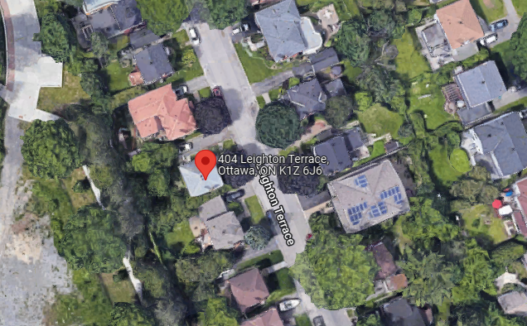

Figure 2 - Zoning Map
Excerpt from: City of Ottawa Zoning By-law 2008-250 Consolidation
R1MM (762) – Residential Zone
