Zoning Map: 1582 County Rd 3, Carrying Place
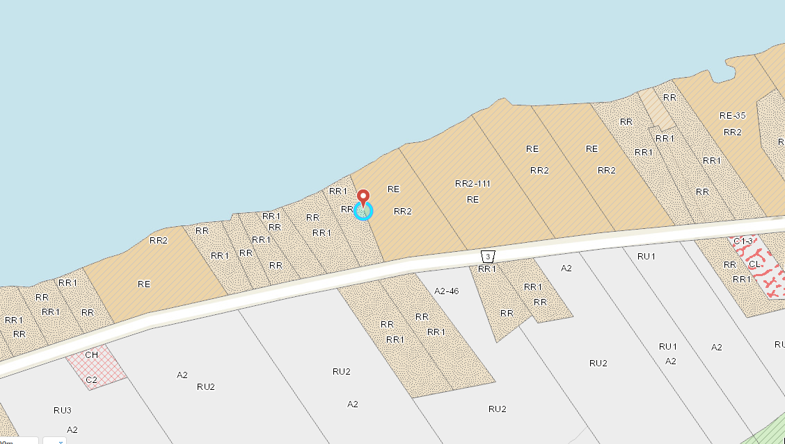
COUNTY OF PRINCE EDWARD COMPREHENSIVE ZONING BY-LAW NO. 1816-2006
RR1 and RR – Rural Residential Zone
Click here for full zoning provision.

